A Project Report on
Agriculture product selling website

Name: Abhishek Jalindar Gaikwad
Type of Project: Web Technology
Language Used: HTML5, CSS3, Bootstrap5 &
Javascript
Date of Submission: 31-03-2025

1.Overview
An agriculture product selling website typically functions as an online platform where users can buy and sell agricultural products. These products could range from seeds, fertilizers, and pesticides to equipment, machinery, livestock, and even organic produce. The primary goal of such a website is to connect farmers, agribusinesses, and consumers in a seamless and user-friendly online environment.

1. User Profiles & Account Management
- Registration & Login: Users (sellers and buyers) can create accounts to manage their orders, purchases, and listings.
- Seller Profile: Sellers can create detailed profiles showcasing their farm, products, certifications, etc.

2. Online Store for Sellers
- Product Management: Sellers can upload, update, and manage their product listings, including setting prices and stock levels.
- Shipping & Delivery Options: Sellers can define shipping methods and delivery charges.

3. E-commerce Features
- Shopping Cart: Buyers can add products to their cart before proceeding to checkout.
- Secure Checkout Process: Buyers can enter shipping details, select payment methods, and complete purchases securely.
- Discounts and Promotions: Sellers can offer discounts or bundle offers to attract buyers.

2.Objective
1. Business Objective:
The business objectives of an agriculture product selling website are essential for guiding its development and ensuring that the platform successfully meets the needs of farmers, businesses, and consumers. These objectives will focus on growth, user engagement, operational efficiency, and sustainability.
1. Increase Market Access for Farmers
- Objective: To provide farmers with a platform that connects them directly to buyers, allowing them to expand their customer base and increase sales.
- Key Actions:
  - Onboarding local and regional farmers to list their products.
  - Helping farmers reach both local consumers and larger B2B buyers (wholesalers, cooperatives).
  - Providing marketing tools to promote their products.

2. Facilitate Easy, Secure Transactions
- Objective: To ensure that the platform provides a seamless, secure, and trustworthy transaction experience for both sellers and buyers.
- Key Actions:
  - Integration of secure payment gateways for smooth transactions.
  - Offering various payment methods (credit/debit cards, mobile wallets, bank transfers).
  - Ensuring transparency with order tracking, shipping, and customer support..

3.Provide a User-Friendly Experience
- Objective: To create a user-friendly platform that allows farmers, businesses, and consumers to easily navigate, make purchases, and manage orders.
- Key Actions:
  - Designing an intuitive, mobile-responsive website for ease of use.
  - Offering customer support (live chat, email, FAQs) for troubleshooting and assistance.
  - Simplifying the checkout process and making it accessible even for users with limited technological expertise.

4. Secure Payment Gateway Integration
- Payment Security: Integration of trusted and secure payment systems (like PayPal, Stripe, or local payment systems) to handle transactions safely.
- Order Confirmation: Upon successful payment, users receive an order confirmation with details and an estimated delivery date.

5. Product Recommendations and Personalization
- AI-Based Recommendations: Personalized product recommendations based on past purchases, browsing history, or user profile information.
- Trending Products: Showcase trending products, seasonal items, or popular products on the homepage to encourage purchasing.

6. Order Management and Tracking
- Order History: Buyers can view and manage their past orders, re-order products, or track the status of current orders.
- Order Tracking: Real-time tracking of orders with shipment and delivery status visible to customers.
- Order Status Updates: Automatic email/SMS notifications for users about the status of their orders (shipped, in transit, delivered).

7. Bulk Ordering and Wholesale Features
- Bulk Discount Options: Allow businesses, cooperatives, or wholesale buyers to purchase agricultural products in bulk at discounted rates.
- Custom Bulk Orders: Enable customers to request custom orders for specific quantities or product variations.

8. Logistics & Delivery Management
- Shipping Options: Multiple shipping methods and rates (standard, express, bulk delivery), catering to the types of products and buyer needs.
- Delivery Time Estimates: Provide estimated delivery times based on customer location and the type of product.
- Local Delivery Partners: Partnering with reliable local couriers to ensure efficient delivery, especially in rural areas.
- Packaging for Agricultural Products: Offer specific packaging solutions for fragile or perishable items like seeds or fresh produce.

11. Product Pricing & Discounts
- Dynamic Pricing: Allow for flexible pricing models, where prices may vary based on order volume, location, or specific product specifications.
- Discounts and Offers: Sellers can offer seasonal discounts, combo deals, or promotions on specific products to encourage more sales.
- Loyalty Programs: Offer loyalty rewards or point systems where users can earn points for purchases that can be redeemed on future orders.

3.Key Features

1. Product Listings and Categories
- Product Catalog: Clear and organized categorization of agricultural products such as seeds, fertilizers, machinery, organic products, tools, etc.
- Detailed Product Pages: Each product should have a dedicated page that includes product images, detailed descriptions, specifications, pricing, availability, and shipping information.

2. User Registration & Account Management
- User Sign-Up/Login: Secure user registration and login systems for farmers, buyers, and sellers. Users can create personal or business profiles.
- Profile Management: Ability for users (buyers and sellers) to manage their profiles, track orders, manage payment information, and view past transactions.
- Seller Profiles: Sellers can create detailed profiles, showcasing their farm or business, certifications, and product offerings.

3. Shopping Cart and Checkout
- Shopping Cart: Users can add products to the cart and view them before proceeding to checkout.
- Multi-Currency and Multi-Payment Options: Offer various payment methods (credit/debit cards, bank transfers, digital wallets, cash on delivery, etc.) and enable support for different currencies.
- Secure Checkout Process: A secure and user-friendly checkout process with the option to enter shipping details, payment information, and review orders.

4 Screenshots
1. Home Page
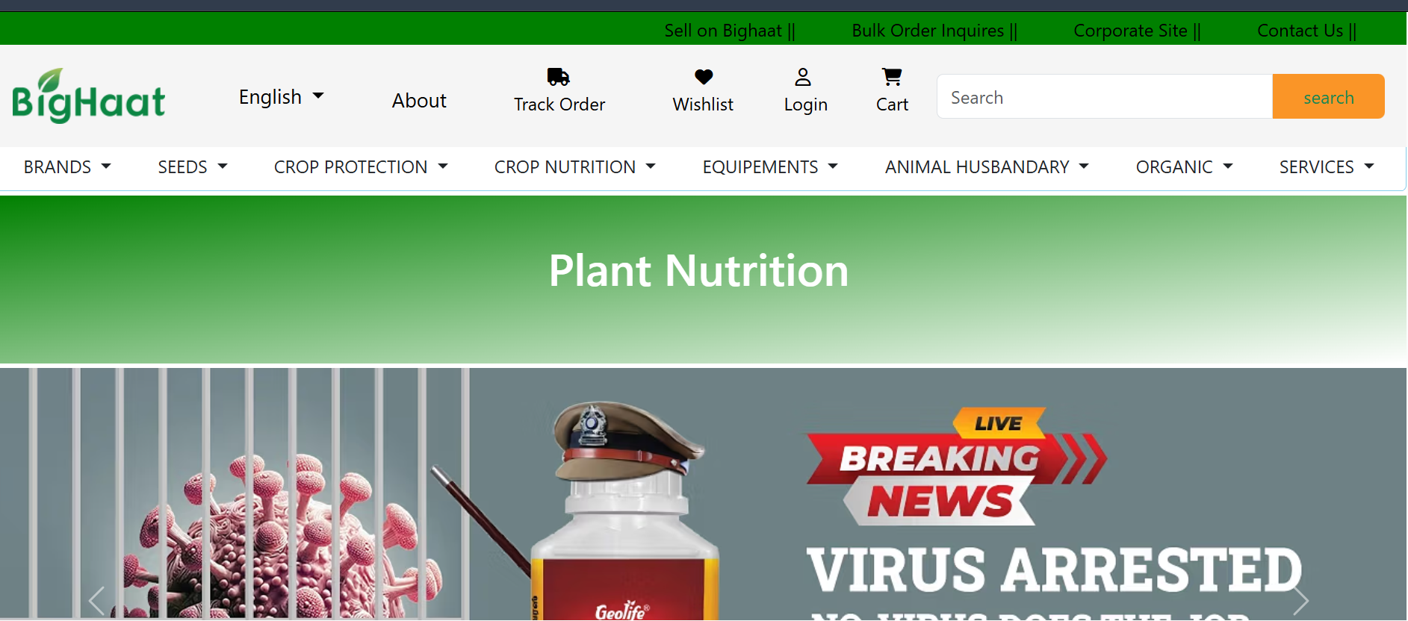
2. Login Page
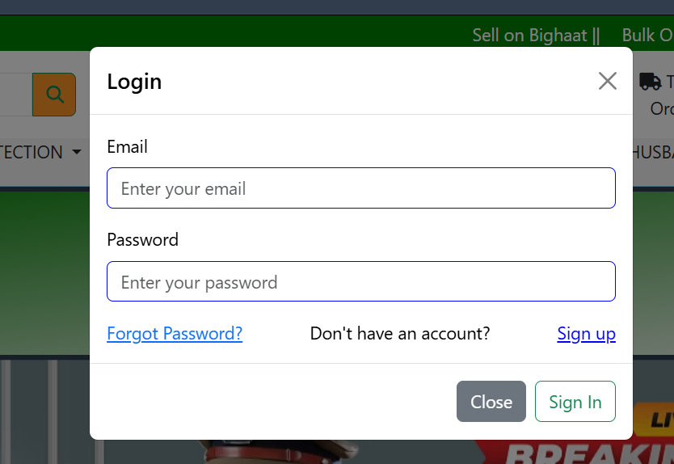

3. Signup Page

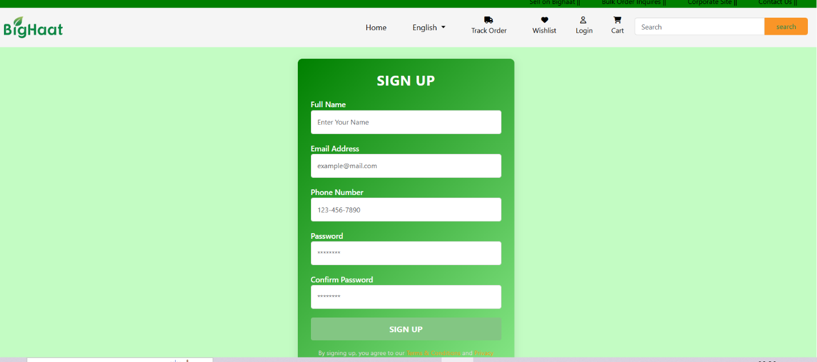
4.Contact Page
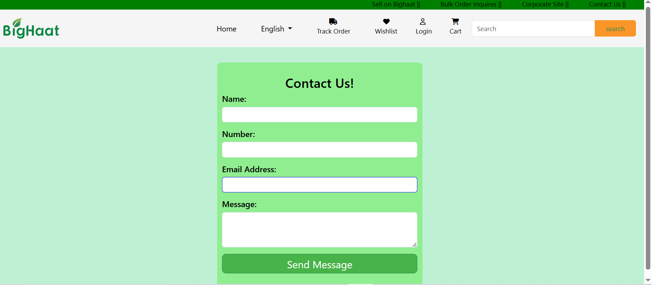

5.Product Page
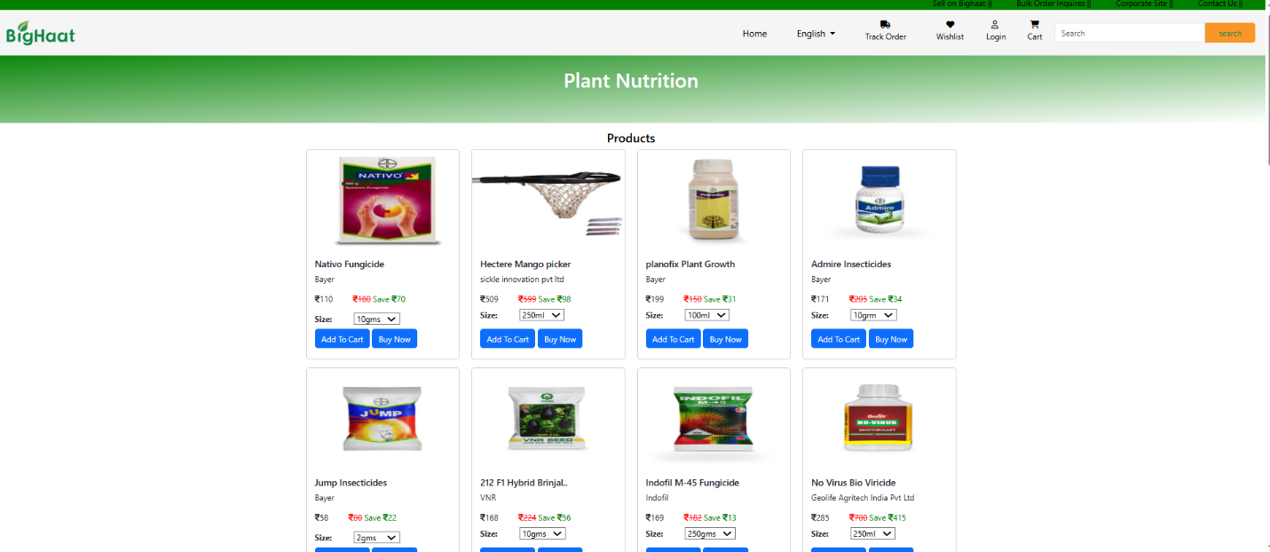
6.track Your Order
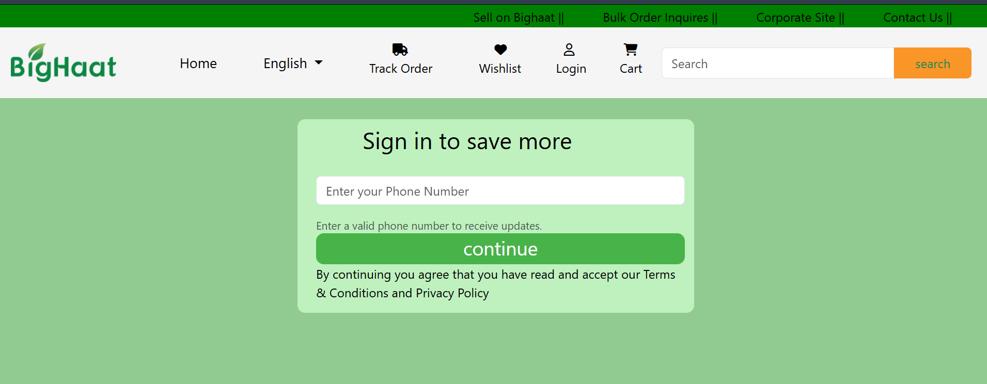

7.Wishlist page
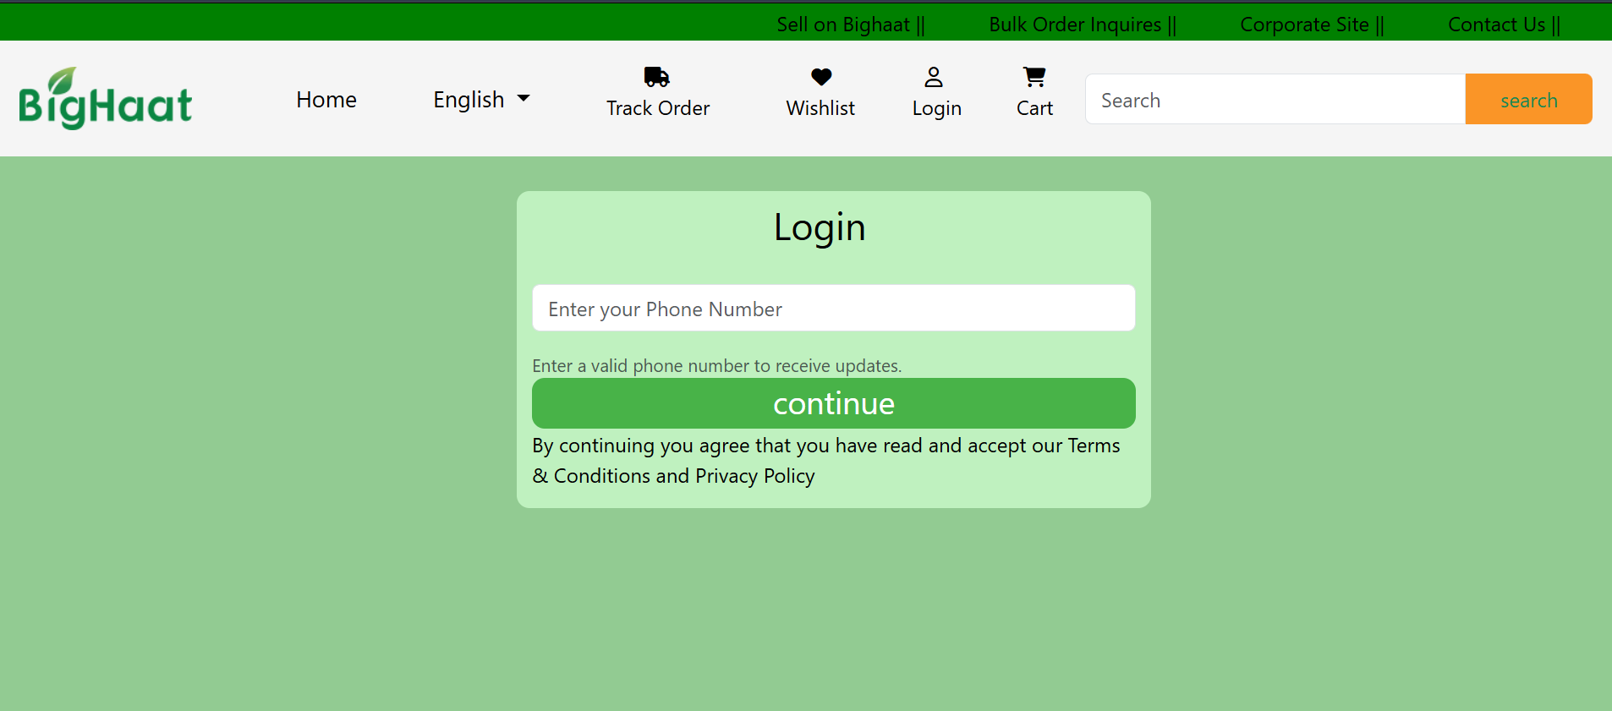

Thank You..

